Green Spaces Strategy 2012–2026 Executive Summary

Oxford has a wealth of superb green spaces. They provide places where people of all ages can relax, play, enjoy nature and take part in recreation or sport. They incorporate important historic landscapes, and include nature reserves, woodland and meadows which provide vital habitats creating environments where biodiversity can flourish.

Oxford’s green spaces enhance its world-famous Cityscape, and greatly add to people’s satisfaction with their local area. They help to bring communities together offering positive activities for people of all ages and offer numerous volunteering opportunities. They act as the City’s lungs and are a vital asset to the local economy. Additional to this they are crucial for maintaining and improving people’s health and well-being. Evidence shows a brisk walk every day, in a local green space, can reduce the risk of heart attacks by 50%, strokes by 50%, diabetes by 50%, fracture of the femur by 30%, colon cancer by 30%, breast cancer by 30% and Alzheimer’s by 25%. Add to this the impact of exposure to nature and green space on stress and mental health and the full picture in relation to health and wellbeing can start to be understoodFF.

As such the green spaces need preserving, protecting and enhancing now and for future generations. This strategy is a key document in helping to support, protect and improve the green spaces to ensure that they meet the needs of the people and visitors to Oxford. It provides a vision and objectives for how green spaces should be planned and managed, providing strong links to the Council’s Corporate Plan.

The strategy has been produced using best practice and guidance from the Commission for Architecture and the Built Environment (CABE) Space documents and assisted by GreenSpace, the national charity which works to improve parks and green spaces. “GreenSpace South East has worked collaboratively with Oxford City Council in the production of this Green Space Strategy. By choosing to work collaboratively Oxford City Council has ensured that this document follows available guidance and good practice. Reviewing progress and priorities at this point will continue to ensure that this strategy is a living document, reflective to the needs of city residents and business. I’m confident that this strategy will be well received by local people and the parks team are focussed on its delivery in the future.”

Consultation over the years has shown both a high level of usage and support for the parks and green spaces and the strategy aims to build on the already existing groups of volunteers who help to manage and protect these spaces.

Some of the proposed improvements will take time which is why this is a 15 year strategy which runs in line with The Core Strategy. However there will be a focus on the next four years with a full review in 2015.
Contents

1.0 Introduction 3

The purpose of the Green Spaces Strategy

Links to the local, corporate and service plans

What does the Green Spaces Strategy cover?

Oxfords Parks and Open Spaces

How does the Green Spaces Strategy fit with other Strategies and Polices?

2.0 Parks and Open Spaces Vision and Aims 6

3.0 Oxford’s Local Quantity Standards 7

4.0 Improving Access to Green Space 10

5.0 Promoting High Quality Green Space 12

6.0 Contribution of Green Space to Biodiversity, Sustainability and Heritage 15

7.0 Contribution of Green Space to Health and Well-being 18

8.0 Community Involvement 20

9.0 Delivering the Strategy 22

Appendices:

1. Maps illustrating Green Space, Play Area and Allotment Distribution
2. Definitions of Large, Medium and Small Parks
3. Extract from Green Spaces Study showing variance via urban village to
quantity standard
4. 1900m Walking Distance to Formal Large Parks
5. Parks and Open Spaces Specification Executive Summary

1.0 Introduction

1.1 Oxford’s parks and open spaces are of great significance. Oxford has been termed an ‘Iconic Landscape’ and is recognised worldwide for its distinctive buildings, skyline of domes and ‘dreaming spires’, interweaving rivers and meadows, uninterrupted views from Shotover, South Park, Raleigh Park, Boars Hill and Wytham, with green connecting corridors. However, these green spaces represent more than just an iconic landscape, they are integral to the life of the City and its economy, and make a significant contribution to improving the outcomes for local people’s health and well-being, help to build stronger, more engaged communities, and give people a greater sense of satisfaction with where they live. They also play a vital role in preserving the City’s cultural heritage and biodiversity.

1.2 The 2009 Oxford City Place SurveyFF showed the importance people give to their local green space. The survey showed that parks are the most used Council Service, 79% of respondents used parks and open spaces at least once a month. They also show that parks have the highest user satisfaction rate, 80%, of all City services. National surveys mirror this importance with 91% of people believing that public parks and open spaces improve their quality of lifeFF.

1.3 Whilst The Place Survey shows support for Oxford City’s Green Spaces is high, the environment in which the service is managed is changing. In October the Chancellor published the Comprehensive Spending Review (CSR) for the period 2011-15. The CSR set out a major programme of public spending cuts and local government cuts. The Leisure & Parks Service plan and the CSR run for four years which is why this strategy is focused on the next four years, but recognising the timescales involved in changing the environment there are longer term objectives running to 2026.

1.4 During the same period the Government also published The Localism Bill which includes measures to strengthen the role of neighbourhoods in helping to plan new developments in their areas. Parks Services already works in a variety of ways with volunteers and will continue to take advantage of these new opportunities for community engagement where it can and will support local residents who wish to get involved in their parks and open spaces.

The Purpose of the Green Spaces Strategy is to:
  - Protect and improving Oxford’s accessible parks and open spaces.
  - Provide a vision, aims, a robust evidence base and, a set of objectives that together
provide a strategic framework for the planning and management of parks and open
spaces.
  - Provide the Council with a robust basis for making development decisions and
negotiating planning gain.
  - Identify ways in which parks and open spaces can be improved in a coordinated
way whilst providing value for money.

Links to the local, corporate and service plans
1.5 Oxford City Council’s Core Strategy 2026 sets out the spatial planning framework for the development of Oxford up to 2026. It was adopted in March 2011. The Green Spaces Strategy fits in with Policy CS21 and CS17 of the Core Strategy.

1.6 Oxford City Council’s Corporate Plan 2011-2015 vision is to remain committed to its core ambition of building a world class City for everyone. The City Council’s corporate priorities are:

- CP1 A vibrant and sustainable economy
- CP2 Meeting housing need
- CP3 Strong and active communities
- CP4 Cleaner greener Oxford
- CP5 An efficient and effective council

1.7 Oxford City Leisure and Parks Service Plan 2011-2015 vision is to provide world class parks, open spaces and leisure opportunities to enhance the quality of life for everyone living, visiting or working in Oxford. The plans objectives are to:

- Support the physical regeneration of Oxford through the delivery of key projects
- Support the social regeneration of Oxford
- Ensure the leisure contract delivers its promise
- Continuously improve our approach to People Management & Equalities
- Continuously improve the operational performance of the service
- Continuously improve the financial performance of the service
- Continuously improve stakeholder relations

What does this Green Spaces Strategy cover?
1.8 The focus is on green space in the City that is freely available to the public irrespective of the landowner for informal recreation, allotment and play spaces. However, the main impetus will be on those areas that are managed by Oxford City Council. It includes green spaces that are managed specifically for recreation such as the Large Parks and other green spaces which are more informally managed for wildlife. It does not include green spaces closed to the public e.g. private gardens.

1.9 Oxford’s playing pitches were audited separately for the Oxford Playing Pitch Strategy that is due to be adopted by the City Council in 2011.

1.10 Oxford City’s projected population is expected to be 156,620 in 2026, a change of 11.3%FF. This rise will result in an increase in demand on the parks and green spaces and will affect the standards and objectives set in the strategy.

Oxfords Parks and Open Spaces
1.11 Appendix one illustrates the distribution of parks and open spaces, play areas and allotments.

Amenity | Numbers
Large Parks | 8 (Including University Park)
Medium Parks | 21
Small Parks | 27 (Inc. 3 owned by Parish Councils)
Nature Parks | 29
Country Park | 1
Ecological Sites of Special Scientific Interest | 3
Geological SSSI’s | 2
Equipped Play Areas | 90
Non-equipped Play Areas | 7
Allotments | 29 are owned by Oxford City Council and seven by others.
Council Cemeteries | 4 (two of which are closed for new burials)
Churchyards | 9 (all of which are closed for new burials)

Notes:
Appendix two explains the hierarchy and definitions used.
The nature reserve and country parks include 295 Hectares (Ha)FF nationally important for
wildlife and 140 Ha internationally important for wildlife.

How does the Green Spaces Strategy fit with other Strategies and Polices?
Green Spaces
Strategy
2012 / 2026
Overarching Strategies: Local Plan, (Local Development Framework), Core Strategy 2026, Corporate Plan, Cultural Strategy, Emerging Leisure Strategy
National/Regional influences:

- Planning Policy Guidance 17
- Green Spaces Better Places
- Living Places: Cleaner Safer and Stronger
- CABE Space Guidance
- Urban Green Nation CABE
- National Charter for Play
Natural England
Strategies

- Playing Pitch Strategy

Delivery & Monitoring

- Site Management Plans

- Specification

- Service Standards

- Local Performance
Indicators
Related/contributing documents
Local Area Agreements
Oxford Open Space Assessment
Asset Management Mapping
2.0 Parks and Open Spaces Vision and Aims

  - A vision statement and aims have been agreed for Oxford’s green spaces.

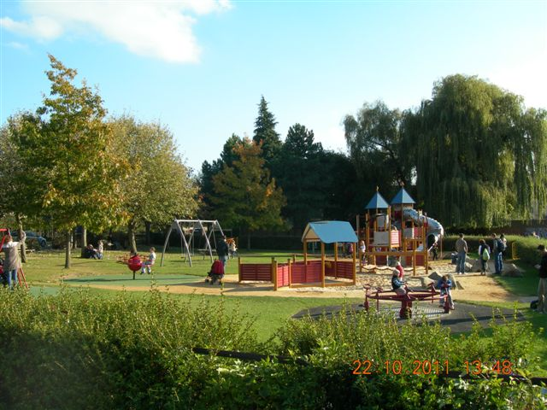  New Hinksey Park Play Area 2010 | “To provide world class parks and open spaces to enhance the quality of life of everyone living, visiting or working in Oxford”
2.2 In order to achieve this vision the following aims are proposed. The objectives to meet these aims are set out in the following 6 chapters.

 |  | Links to Corporate Plan
Aim 1 | To establish a minimum standard of green space provision to ensure that Oxford has an agreed amount of green and play spaces to meet existing and future needs of residents, workers and visitors |  | CP1  CP4
Aim 2 | To ensure everyone living, working and visiting in Oxford has easy access to open space |  | CP1  CP4
Aim 3 | To achieve high quality green spaces across Oxford, including spaces that are nationally recognised for their quality and attractions |  | CP5
Aim 4 | To promote the central role that green spaces play in contributing to the City’s biodiversity, sustainability and heritage |  | CP1  CP3
Aim 5 | To promote the central role that green spaces play in contributing to the City’s health and well-being |  | CP3
Aim 6 | To support community cohesion and community involvement in the stewardship of green spaces |  | CP1  CP3
3.0 Oxford’s Local Quantity Standards

Aim – 1 To establish a minimum standard of green space provision to ensure that Oxford has an agreed amount of green spaces and play spaces to meet existing and future needs of residents, workers and visitors | 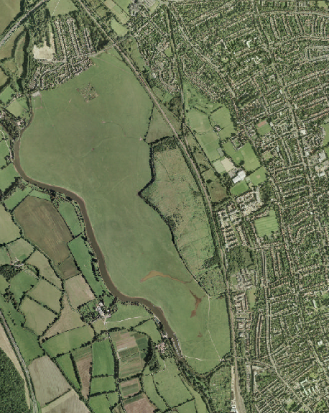  Port Meadow

3.1 This strategy sets out Oxford’s parks and open spaces standards for quantity, i.e. how much green space there should be. The Councils Core Strategy 2026 standard has been set based on the 2006-2011 Green Spaces Strategy and data provided for the 2005 Oxford City Green Spaces StudyFF, and local needs, set at 5.75 ha per 1,000 population. This does not necessarily mean that the standard of 5.75 ha should be applied as a requirement within all new developments, as small new developments would not be able to provide usable public green space on site. It is important that the right types and quality of public green space are provided in the right locations.

3.2 The Core Strategy states whilst the standard cannot be applied directly to all new developments, it is important that new development does not make the balance worse. Larger developments will be expected to provide on-site green space where this will enhance the range of green space already available in the area. Other developments need to make financial contributions to improve the quality of existing green space, so that it can be used more intensively. Opportunities will be sought to open up new areas of green space to the general public, and new developments may be expected to provide such access. This could include, for example, improvements to public rights of way. Detailed in Policy CS21 and CS17 of the Cores Strategy 2026.

Objective 01: Oxford’s Accessible Green Space Standard
To achieve the provision of an overall average of 5.75 hectares of accessible green space per 1000 population so that:
- Oxford has a good provision of accessible green space.
- The provision of accessible green space is increased as the population grows.
- Oxford has a good balance of different types of accessible green space.

3.3 Increases in Oxford’s population are constantly putting pressure on this standard, and based on estimated 2008 population figures the current provision is currently 5.26 ha per 1000 population. This is comparable to other similar authorities with Plymouth having a standard of 5.09 ha per 1000 population. Appendix three shows the surplus and deficit across the City based on Oxford Green Space Study, Scott Wilson 2005.

3.4 The standard will be used to identify parts of the City that are currently deficient in accessible green space. Therefore it will inform proposals to improve green space in different parts of the City.

Objective 02: Oxford’s Playing Pitch Strategy
To deliver the recommendations in the playing pitch strategy.

3.5 Oxford Playing Pitches Strategy is a document that provides a strategic assessment of the playing pitch provision in Oxford in addition to provision of outdoor sports facilities. The key objectives of producing the Playing Pitch Strategy are to:

1. Ensure that Oxford has the right number of playing pitches, to the right standard and in the right places.
2. To protect existing playing pitch provision from competing demand within the City.
3. To achieve a higher standard of pavilion provision for its playing pitches.
4. To identify where developer contributions or funding can be used to improve and maintain pitch provision and ancillary facilities.
5. To help increase participation in sport and physical activity (previously NI8).

Objective 03: Oxford’s Allotment Standard
To retain at least 1 plot per 125 head of population.

3.6 An Allotment standard needs to be set because there is an increasing interest in community food growing. It provides big returns on health and nutrition, learning about where food comes from, improved community resources and reduced food miles.

3.7 The National Society Association of Allotments recommend one plot per 125 head of population (assuming 2.5 occupants per household) Oxford currently provides 1 plot per 61 head of population. In accordance with national guidance on effectively managing allotments "A Place to Grow"FF we need to ensure that we are maximising the use of the current sites before any costly changes, such as brining back disused allotments, are considered.
4.0 Improving Access to Green Space

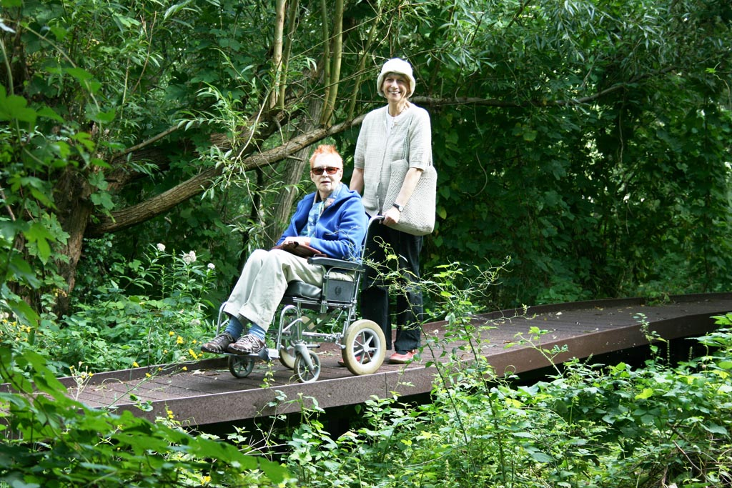  The Trap Grounds Boardwalk | Aim – 2 To ensure everyone living, working and visiting in Oxford has easy access to open space

4.1 This strategy sets out Oxford’s parks and open spaces local distance standards for green space, i.e. how far people should have to travel to their nearest green space. Natural England believe that everybody should have access to good quality green space near to where they live as “Natural green places provide natural solutions to many 21st century diseases – obesity and inactivity, heart disease and strokes, depression and mental illness”FF This aim seeks to remove existing deficiencies and ensure good access.

Objective 04: Improving local access to Green Space
To ensure that people do not have to walk more than 1900m to their nearest Large Park, not more than 750m to their nearest Medium Park and not more than 400m to their nearest Small Park. This standard will be applied to all new developments as well as existing residential areas.

Where deficiency in access to green space is identified then the following approach will be applied:
- Where deficiency is due to severance factors such as lack of pedestrian crossings then seek to address this by offering new access points and safe routes.
- Look at opportunities to utilise existing inaccessible green space by opening it up for public access.
- Seek opportunities to create new accessible green space.
- Where none of the above three options are available, enhance the quality of existing accessible green space.

4.2 The access standard is based on survey data from the Parks Customer Satisfaction Survey, the consultation carried out in the Oxford City Green Space Study by Scott Wilson and best practice guidance including the Mayor’s of London’s Guide to preparing Open Space Strategies. Appendix four shows 1900m walking distance to formal large parks.

4.3 Local strategies will have to be developed to address deficiencies as circumstances change from one area to another.

Objective 05: Improve Accessibility in and Connectivity Between Sites

4.4 Improving access will mean that walking distance standards are easier to achieve.

4.5 Where budgets allow recommendations from Disability Discrimination Act audits should be applied, to ensure gates, pathways, signage etc are accessible to all.

4.6 Work with partner organisation such as Sustrans Safe Cycle routes and the Environment Agency to enhance the Thames Path, the only lowland National Trail area. It is a seamless rural environment passing through Oxford, with glimpses of the built environment behind. The stretch through Oxford has been referred to as one of the highlights of the route.
5.0 Promoting High Quality Green Space
Aim 3 - To achieve high quality green spaces across Oxford, including spaces that are nationally recognised for their quality and attractions | 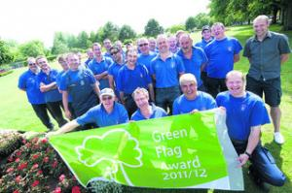Receiving The Green Flag Award 2011
5.1 This chapter sets out Oxford’s quality standard for green space. The aim seeks to raise the quality so as to improve peoples’ enjoyment and satisfaction. This is a standard set across the City so that all residents, regardless of location, receive the same quality of open spaces.

5.2 There is currently an uneven distribution of Green Flag Parks across the City. South Oxford does not have a park with the award, so it is proposed to make Blackbird Leys Park, which is located in an area of deprivation, into Green Flag Standard.

Objective 06: Green Flag Parks
To increase the number of Parks that achieve the Green Flag Award and the Green Flag Community Award.

5.3 It is proposed to retain the existing 4 Green Flag Awarded parks and bring up to standard a further park by 2015. It is proposed to bring 3 parks to Green Flag Community Award (formally Green Pennant) status by 2015.

Objective 07: Increase the Standard
To increase the standard of all “Medium” and “Small” green spaces to achieve an average quality inspection score of 3 or 4.

5.4 The Parks Services currently inspects a minimum of 20 parks and open spaces each month using a scoring card system. A number of Medium and Small parks fall below their potential. While the standard aims to bring all Medium and Small parks to “good” this does not mean that the service should not strive for excellent and where excellent is achieved it should not be allowed to slip.
Recorded Score | Description
1 | Failing
2 | Poor
3 | Sufficient
4 | Good
5 | Excellent and World Class

Objective 8: High Quality Design
To ensure that all of Oxford’s parks and open spaces are designed to the following principles:
- Safe and accessible to all, clearly marked entrances and internal paths, including provision for pedestrians and cyclists.
- Welcoming, with well-maintained entrances and signage.
- Designed to enhance natural surveillance.
- Clean and well maintained.
- Designed to be adaptable to climate change.

5.5 These design principles follow CABE Space and Green Flag design guidelines.

Objective 09: High Standard of Cleanliness
Achieve the Service Standards set out in the specification (see appendix five).

5.6 The management and maintenance of Oxford’s parks and open spaces need to continually improve. When the Grounds Maintenance Specification was written in 2010, service standards were applied. This ensures that the horticultural aspects, such as grass cutting, as well as the cleanliness aspects such as littering and dog fouling are kept to a high standard, thereby reflecting the needs of the users.

Objective 10: Creating a Skilled Workforce
To provide the Parks workforce with the necessary horticultural and professional skills to contribute towards the world class vision.

5.7 In order to provide high quality parks and open spaces the Parks Service needs to invest in its workforce. A skills gap and an aging workforce has been identified across green space management nationally, and objective 10 helps to address this locally.

Objective 11: Retain ISO9001 and gain ISO1401

5.8 ISO9001 relates to quality standards designed to help Parks Services ensure that they meet the needs of customers and other stakeholders. It has been shown that superior operational performance can be achieved upon implementing ISO9001.

5.9 ISO14001 is the internationally recognised standard for the environmental management of businesses. It prescribes controls for those activities that have an effect on the environment. These include the use of natural resources, handling and treatment of waste and energy consumption.

Objective 12: High Quality Play Spaces
To apply the following principles to the location and design of play space:
- The Play England manual ‘Design for Play’.
- Royal Society for the Prevention of Accidents design guides.
- The Association of Play Industries design guide lines.
- Play spaces should be located where there is good natural surveillance from street and neighbouring houses.
- Play spaces should be located on accessible green space where feasible and include elements of natural and free play.
- A buffer zone should be provided around play areas.
- All play areas should be designed to be inclusive for children and young people with disabilities.
- Play Areas should be designed to create a variety of facilities in distinctive spaces which enhance the local character and environment.

5.10 The Play England manual ‘Design for Play’ identifies the following principles for designing successful play spaces:
- Are bespoke
- Are well located
- Make use of natural elements
- Provide a range of play experiences
- Are accessible to both disabled and non-disabled children
- Meet community needs
- Allow children of different ages to play together
- Build in opportunities to experience risk and challenge
- Are sustainable and appropriately maintained
- Allow for change and evolution

Objective 13: – High Quality Tree Management

5.11 Trees play a key role in defining the landscape of a green space, they also provide vital habitat for wildlife and help make places more comfortable to live in for people by providing shading and cooling and filtering pollutants from the air.
6.0 Contribution of Green Space to Biodiversity, Sustainability and heritage

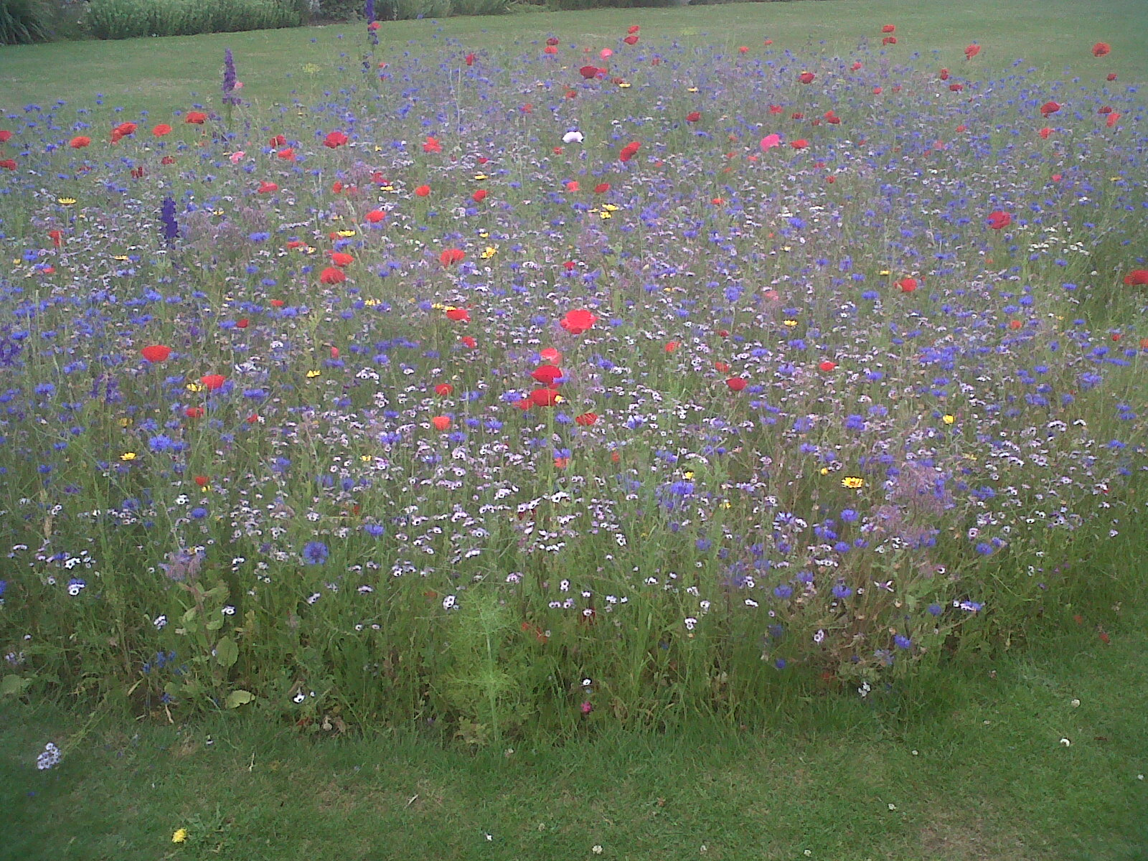  Wild Flowers in Cutteslowe Park 2011 | Aim 4 - To promote the central role that green spaces play in contributing to the  City’s biodiversity, sustainability and heritage

6.1 This chapter will identify objectives that:
- support the City Council’s target to reduce its carbon footprint
- identify how Parks Services can adapt to and mitigate the impact of climate change
- conserve and encourage biodiversity
- protect and preserve heritage

6.2 Since 2005 Oxford City Council has had a Climate Change Action Plan and in April 2008 it agreed the carbon management plan called Getting Our House in Order. Oxford City Council has committed to:
- Reducing Council CO2 emissions by 25% by March 2011 and then 3 per cent year on year thereafter
- Raising awareness and understanding of climate change
- Increasing the energy efficiency of new developments
- Transforming Oxford into a sustainable City

6.3 Low Carbon Oxford was launched on 14 October 2010 to ensure Oxford’s future as a sustainable and low carbon City. The initiative, which is one of the first in the country, started a programme of co-operation that will help reduce the City’s carbon footprint. In 2011 Oxford City Council was the first UK local authority to be awarded the British Standards Institution Kitemark for energy reduction. This independent verification scheme recognises the outstanding carbon management practices and commitment to ongoing improvement.

6.4 Local authorities have a statutory duty on biodiversity (section 40, Natural Environment and Rural Communities Act 2006). “Every public authority must, in exercising its functions, have regard, so far as is consistent with proper exercise of those functions, to the purpose of conserving biodiversity. Conserving biodiversity includes, in relation to a living organism or type of habitat, restoring or enhancing a population or habitat”.

6.5 Oxford City Council manages three Ecological Sites of Special Scientific Interest (SSSI’s) these are Port Meadow, Lye Valley and Shotover Country Park. As well as two Geological SSSI’s which are Magdalen Quarry and Rock Edge.

6.6 A wildlife corridor is a link of wildlife habitat of generally native vegetation, which joins two or more larger areas of similar wildlife habitat. Corridors are critical for the maintenance of ecological processes including allowing for the movement of animals and the continuation of viable populations. They can also provide opportunities for walking and cycling which offer both health benefits through exercise and environmental benefits through reducing car journeys (see objective 18).

Objective 14: Promoting Sustainability within the Parks Service
To proactively adopt and promote practices that contribute to the sustainable management of parks and open spaces and help to reduce the City’s carbon footprint.

Objective 15: Adapting to Climate Change
To proactively adopt and promote practices that recognise the key role that Oxford Parks and Open Spaces can play in the City’s adaptation to climate change.

Objective 16: Protect and enhance Biodiversity
To ensure the protection of internationally, nationally and locally important sites of biodiversity interest (Special Areas of Conservation, Sites of Special Scientific Interest, Local Wildlife Sites and Sites of Local Importance for Nature Conservation).

6.7 Aerial photography and small-scale excavations reveal that the green spaces immediately to the North of the City, Port Meadow, Wolvercote Common and the University Parks, are rich in archaeological remains. All three sites contain remnants of Bronze Age Barrow cemeteries, and at Wolvercote Common this includes a surviving earthwork mound which formed part of one of the barrows. There are also extensive remains associated with Iron Age and Roman-British settlement, and, although less easy to detect without open area excavation, it is likely there is settlement activity contemporary with the Bronze Age Barrows and there may even be evidence of Neolithic activity closer to the river on Port Meadow.

6.8 There was a Neolithic Long Barrow on the ridge which runs though Shotover County Park, but this was sadly destroyed by tank exercises during the Second World War. However, it is possible that other features contemporary with this monument may survive at this site. Other notable sites of historic importance within the City’s green spaces include Bury Knowle House with its landscaped park and Ha HaFF, the ruins of the 12th-century Godstow Nunnery, and an extensive area of earthworks in South Park, representing the remnants of medieval ridge and furrow ploughing.

6.9 Ensuring that the historic and archaeological fabric of these sites is preserved, whilst at the same time encouraging the use of these open spaces for recreation, sports and events, provides a challenge and it is vital that strategies are put in place to avoid conflict between these aims.

Objective 17: Protect and preserve the archaeological features and heritage in Parks and Open Spaces

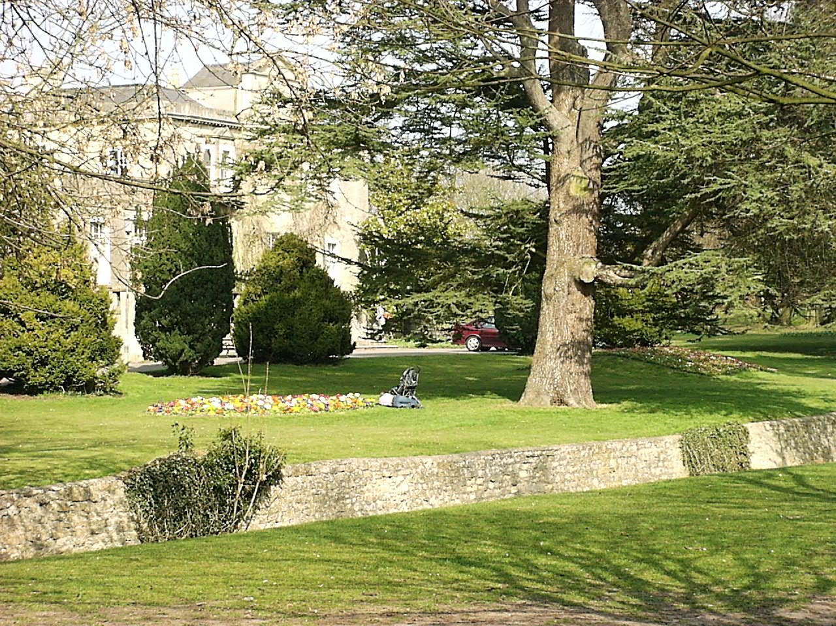
Bury Knowle Park House and Ha Ha

7.0 Contribution of Green Space to Health and Well-being

Aim 5 - To promote the central role that green spaces play in contributing to the City’s health and  well-being | 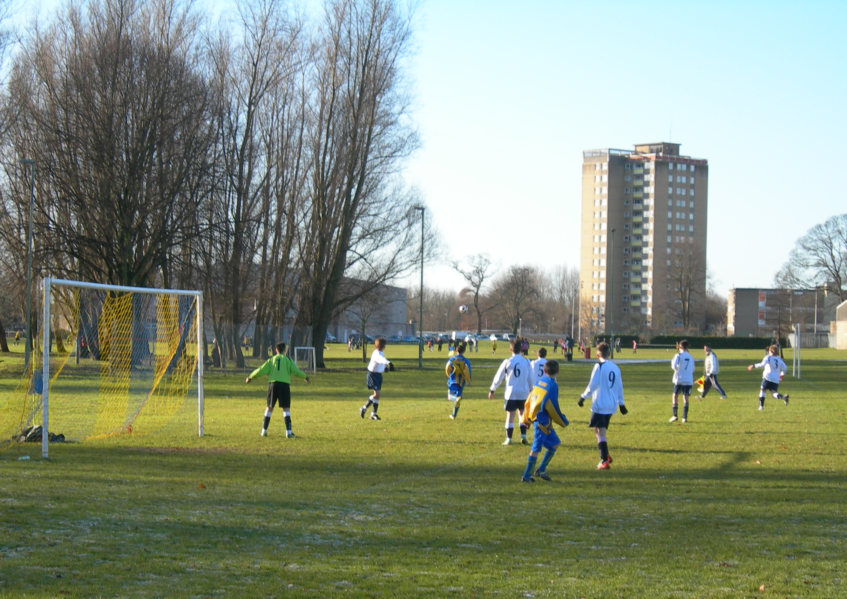  Football in Blackbird Leys Park

7.1 There are worrying trends relating to the nation’s health. Obesity and less active lifestyles have led to an increase in preventable diseases which are placing increasing pressures on the National Health Service. Around 8% of annual deaths in Europe (at least one in 13) have been attributed to overweight and obesity. Green spaces provide a wealth of opportunities for exercise and sport. Evidence shows a brisk walk every day (in a local green space) can reduce the risk of heart attacks by 50%, strokes by 50%, diabetes by 50%, fracture of the femur by 30%, colon cancer by 30%, breast cancer by 30% and Alzheimer’s by 25%. Add to this the impact of exposure to nature and green space on stress and mental health, on aggression and violence within inner City communities and on Attention Deficit Hyperactivity Disorder amongst children, and the full picture in relation to health and wellbeing and access to green space can start to be understoodFF. The health costs of inactivity in Oxford is at least £2million a yearFF.

This chapter will identify objectives that:
- promote connectivity between spaces for wildlife, walkers and cyclists
- work with partners to promote the health benefits of parks and open spaces
- increase the educational opportunities in parks and open spaces.

7.2 Wildlife corridor’s as explained in section 6.6 are not only important for wildlife, but for recreation too.

Objective 18: Promoting Links between Green Spaces
To work with transport planners to identify opportunities to increase the number of safe walking and cycling routes.

7.3 The health benefits of parks and open spaces have already been well documented in this strategy. Schemes such as Oxford Health Walks have received a national award from Walking for Health. The short organised walks around Oxford are led by volunteers and aim to keep people healthy; mentally and physically. The award means that Oxford Health Walks will benefit from being formally recognised by health professionals, prospective partners and funders.

Objective 19: Promote the Health Benefits of Parks and Open Spaces
To work with health partners and National Governing Bodies of Sport to promote new and existing projects in which parks and open spaces can be used to improve health to make stronger and more active communities.

7.4 Oxford is renowned for being a centre of academic excellence. This can provide a mutually beneficial situation whereby the Parks Service can benefit through research, internships etc and the schools can benefit through access to outdoor learning space.

Objective 20: Expand on the Opportunities for and from the Education Sector
Promote the educational benefits of Parks and Open Spaces as an outdoor learning environment for local schools and higher education.
Establish closer links with Oxford’s education institutions for the benefit of the parks and opens spaces through internships, surveys
To establish clear, well promoted employment pathways that are accessible to all.

8.0 Community Involvement

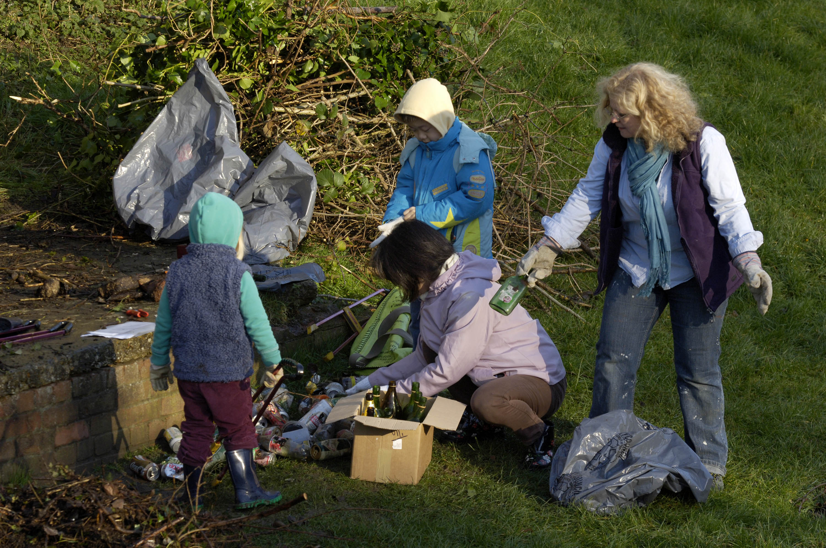  Friends of Quarry Hollow Park | Aim 6 - To support community cohesion and community involvement in the stewardship of green spaces.

8.1 The Big Society is the flagship policy idea of the 2010 UK Conservative Party general election manifesto. It now forms part of the legislative programme of the Conservative – Liberal Democrat Coalition agreement. The aim is “to create a climate that empowers local people and communities”. The Localism Bill, published in December 2010, aims to make it a reality. The priorities are:
- Give communities more power (localism and devolution)
- Encourage people to take an active role in their communities (volunteerism)
- Transfer power from central to local government
- Support co-ops, mutual’s, charities and social enterprises
- Publish government data (open/transparent government)

8.2 The leisure sector is already well aware of the benefits of volunteering, both to the volunteer, by offering training, work experience, education and social engagement, and to the Parks Service and local tax payer, by offering free labour to supplement limited resources at a time of financial restraint. Therefore the service has utilised volunteers for many years. Nationally well over half a million individual volunteers each year, represented by thousands of community groups, working in tens of thousands of communities, give up their time freely and passionately. Whether helping to improve a council managed space or, looking after community managed land, created by local communities, for local communitiesFF.

8.3 Locally, at the time of writing, Parks Services supports 14 Friends Groups who work approximately 218 hours monthly. Volunteering empowers local people to take more control of their environment and gives them opportunities to become more active in their community. These people lead by example, and positively influence and change the behaviour of others. Green space volunteering is often the catalyst for wider participation, the development of community leaders and wider community improvement. A good example are the volunteers who lead health walks in Oxford’s parks.

8.4 It is therefore crucial that this strategy builds on and improves the volunteering opportunities that are already in place.

Objective 21: Community Involvement
To support new and existing community involvement in the design, management and enhancement of Parks and Open Spaces.

8.5 In Oxford there are a number of excellent examples of community led green spaces, such as Milham Ford Nature Park cared for by the New Marston Wildlife Group. There are also many Friends of Groups that cover City Park’s, Play Areas and even disused Cemeteries.

Objective 22: Increase the numbers of active volunteers
To engage with businesses, scouts, churches, schools, colleges, the health sport and physical activity sector to increase the number of volunteers.

9.0 Delivering the Strategy

9.1 The detailed actions necessary to deliver the vision, aims and objectives adopted in this strategy are set out in the action plan. For each objective a set of actions is given with timescales and those responsible for delivery. The action plan will be reviewed and updated yearly until the end of the strategy period.

9.2 The Green Spaces Strategy action plan will be delivered using the existing revenue budget. However as a result of the comprehensive spending review, the department has had to make efficiencies over the next four years to this revenue budget. In order to maintain a high level of service, and still deliver, the service is looking at efficiency savings, income generation and greater use of volunteers.

Action Plan
Aim – 1 To establish a minimum standard of green space provision to ensure that Oxford has an agreed amount of green spaces and play spaces to meet existing and future needs of residents, workers and visitors

What do we want to achieve? | How are we going to do it? | Timescale | Responsibility for delivery
Objective 01: Oxford’s Accessible Green Space Standard | The Oxford Standard will help to inform the Community/Neighbourhood Plans. Areas where there is a deficiency will be identified and recommendations made.  Where a green space is under-used due to anti-social behaviour the Park Rangers will work with partners to tackle the anti-social behaviour and achieve legitimate use. | 2012 onwards  When applicable | P&O Spaces / Communities and Neighbourhood Team  All stakeholders
Objective 02: Oxford’s Playing Pitch Strategy | To deliver the recommendations in the Playing Pitch Strategy. | See Playing Pitch Strategy
Objective 03: Oxford’s Allotment Standard | Continue to build on these relationships on the relationships with the associations.  Attain updated figures for the number of plots, occupancy of sites and accurate waiting list data. Each site will be asked to submit this data on a quarterly basis and develop a checking system to reduce multiple site holders.  100% utilisation of current allotments. | Throughout strategy  2013  2012 | Horticulture and Landscape Manager  Horticulture and Landscape Manager  Horticulture and Landscape Manager

Aim – 2 To ensure everyone living, working and visiting in Oxford has easy access to open space

What do we want to achieve? | How are we going to do it? | Timescale | Responsibility for delivery
Objective 04: Improving local access to Green Space | Work with the County Council Highways and Direct Services to identify and remedy ‘severance’ factors that hinder access to green spaces and provide solutions e.g. safe pedestrian crossings  The Oxford Accessibility Standards will help to inform the Community / Neighbourhood Plans. Areas where there is a deficiency will be identified and recommendations made. | 2016  2013 | County Council / Parks Development / Direct Services  City Leisure / Planning /  Communities and Neighbourhood Team
Objective 05: Improve Accessibility in and Connectivity Between Sites | Work with Unlawfully Moored Boats (UMBEG) which clears areas of the tow path where there has been anti-social behaviour, unlawfully moored boats to improve accessibility.  Consult on increasing the number of Safe Cycle routes to school through Large Parks and implement where appropriate.  Develop a plan to implement prioritise and implement access improvements that have been identified in the disability access audits. | Throughout strategy  2016  2012 | UMBEG / Park Rangers and Operational Manager  Sustrans / Development Officers / County Council  Parks Development Officers / Access Officer

Aim 3 - To achieve high quality green spaces across Oxford, including spaces that are nationally recognised for their quality and attractions

What do we want to achieve? | How are we going to do it? | Timescale | Responsibility for delivery
Objective 06: Green Flag Parks | Achieve five Green Flags in a way that is not detrimental to the other parks, one of which being in the south of the city.  Encourage local groups to go for Green Flag Community Award (Formally Green Pennants). | 2012  2012 | P&O Spaces Manager  Parks Development Officers
Objective 07: Increase the Standard | Work to existing specification which will automatically start to bring up the standard of the Medium or Small parks which currently fall below.  Develop site Management Plans for all Large Sites, along with generic site management plans sites for Medium and Small Parks.  Develop a volunteers action plan opportunities. | Throughout strategy  2020  2012 | P&O Spaces All Teams  Development Officers  Development Officers
Objective 08: High Quality Design: | Through the application of best practice design principles and utilise in-house skills and specialist where appropriate.  Through site management plans. | On all new play areas  Throughout strategy | P&O Spaces All Teams  P&O Spaces All Teams
Objective 09: High Standard of Cleanliness | Achieve performance indicator set in Corporate Plan (2011-2015 to empty 86% of all bins every week).  Review every 6 months the specific team created to ensure high standard of cleanliness.  Utilise the Community Payback Scheme to clear litter hot spots.  All parks staff trained to issue Fixed Penalty Notices. | 2015 then yearly  6 monthly  Throughout strategy  2013 | Litter Team and Operational Manager  Litter Team and Operational Manager  Probation Service  All staff
Objective 10: Creating a Skilled Workforce | Through expansion of the apprenticeship scheme to 3 (2015) and 4 (2026), subject to an appropriate curriculum becoming available from local colleges.  Through performance management, the implementation of the training matrix and the appraisal system. Keep training up to date with relevant legislation.  Develop clear employment pathways. | 2015 / 2026  Yearly  2012 | Cemeteries Manager  All Staff  P&O Manager
Objective 11: Retain ISO9001:2008 and achieve ISO14001 | Allocating dedicated officer time to achieve awards.  ISO9001 – monthly internal audits and annual external audit.  ISO14001 – work with contractor to compile and create relevant procedures to achieve award. | 2012  Monthly and yearly  2012 | Development Officers  Development Officers  Development Officers
Objective 12: High Quality Play Spaces | Consultation on introducing “No Smoking Zones” in play areas.  All new and enhanced play space to be designed using  The 10 principles for play as set out by Play England in the “Design for Play" manual. | 2015  On all new play areas | Development Officers  Landscape Team / Groundwork
Objective 13 – High Quality Tree Management | Work to the adopted Tree Policy to continually provide quality tree management.  Cyclical inspections on a three year rolling programme to determine and complete required works in a timely manor. | Throughout strategy  3 year inspections | Tree Team  Arboriculture Officer

Aim 4 - To promote the central role that green spaces play in contributing to the City’s biodiversity. Sustainability and heritage

What do we want to achieve? | How are we going to do it? | Timescale | Responsibility for delivery
Objective 14: Promoting Sustainability within the Parks Service | Recycle 100% of tree produce for biomass.  Ensuring that Low Carbon Oxford recognise the role that green spaces can play in mitigating effects of Climate Change so that the potential benefits of green space for the City as a whole can be maximised.  Provide a peat free service - Source suppliers who use peat free compost. | Yearly  2025  2015 | Tree Team  P&O Spaces / Low Carbon Oxford / Sustainable Energy Officer  Operational Manager
Objective 15: Adapting to Climate Change | Use water retaining pellets in flower beds, hanging baskets, shrub beds to reduce the amount of watering required.  Where possible plant perennials and reduce bedding plants.  Broaden tree species selection to cope with climate change.  Plant 100 new trees planted per year | 2012 onwards  2012  2016  Yearly | Grounds Maintenance Team  Grounds Maintenance Team  Arboriculture Officer  Arboriculture Officer
Objective 16: Protect Biodiversity and allow it to flourish | Undertaken biodiversity surveys for each site and update the specification to take account of any changes.  Act on national guidance and best practice guidelines, e.g. DEFRA hedge cutting and review the specification accordingly in relation to aspects such as habitat piles from cuttings for invertebrates, reptiles and small mammals.  Analyse grass cutting regimes and machinery used, review changes to accommodate best practice to encourage biodiversity. E.g. leaving cuttings in piles on site to be used by invertebrates and reptiles.  Audit current practices to determine where pesticides are being used, for what purposes and which chemicals are used. Particular attention should be paid to fine turf areas, rose gardens and hard surfaces.  Implement organic cultural methods or Integrated Pest Management (IPM) strategies in parks, and seek alternatives to chemical pesticides where possible.  Management Plans for Port Meadow and Shotover. Management statements for all other countryside sites. Consult relevant local groups regularly on proposed management.  Work with Royal Society for Protection of Birds and Berks, Bucks, Oxon Wildlife Trust on making Upper Thames Valley, its tributaries and Oxford Meadows a pilot Nature Improvement Area (NIA). This will include Port Meadow, Iffley Meadow and possibly Long Bridges and Meadow Lane Nature Reserves. | 2015  2015  2013  2015  2015  2020  2012 onwards | Horticulture and Landscape Manager  / Volunteers / Universities  Landscape and Horticulture Manager / Countryside Team  P&O Spaces All Teams  P&O Spaces All Teams  Grounds Maintenance Team  Landscape and Horticulture Manager / Countryside Team / Development Officers  Landscape and Horticulture Manager / Countryside Team
Objective 17: Protect and preserve the archaeological features and heritage in Parks and Open Spaces | Enforce the byelaws to deter metal detecting, bottle digging, unauthorised vehicle use and other activities which may damage archaeological remains.  Closely monitor the potential impact that events and other activities may have on historic landscapes and fabric, and, where necessary, take action to limit or preclude such activities where there is a clear risk of significant erosion or damage. | Throughout strategy  Throughout strategy | P&O Spaces  P&O Spaces

Aim 5 - To promote the central role that green spaces play in contributing to the City’s health and well-being

What do we want to achieve? | How are we going to do it? | Timescale | Responsibility for delivery
Objective 18: Promoting Links between Green Spaces | Include options for linked green spaces within the Community / Neighbourhood Plans.  Establish green walking and cycling routes throughout Oxford including signage. | 2015  2020 | P&O Space Manager  P&O Spaces / Sustrans
Objective 19: Promote the Health Benefits of Parks and Open Spaces | Continue to achieve the Allotments standard.  Develop further links with the local health service to promote physical activity within parks and open spaces.  Free training for volunteer leaders of health walks.  Through working with Sports Development Team to encourage external clubs to utilise parks. E.g. Tennis Coaching, fitness classes etc.  Monitor usage in parks and play areas  Promote parks through the delivery of the Parks and Open Spaces Marketing Plan.  Increase free opportunities to exercise.  Monitor the effects (using PCT standard Health Questionnaire) in order to gather a robust evidence base.  Explore partnerships with Fusion Lifestyle | Yearly  2015  2015  2015  2014  2012  2012  2015  2012 | Horticultural and Landscape Manager  Health Service / Sports Development  Sports Development  Sports Development  Groundwork / Development Officers  Development Officers  All  Parks and Open Spaces Manager
Objective 20: Expand on the Opportunities for and from the Education Sector | Encourage University students to undertake dissertations and research projects in parks and open spaces.  Work with local schools to become more involved in parks and open spaces either as outdoor classroom, education about the environment e.g. pond dipping to gain a greater understanding and respect for parks and open spaces.  Develop clear career pathways | 2015  2015  2012 | Development Officers  Development Officers  Parks and Open Spaces Manager

Aim 6 - To support community cohesion and community involvement in the stewardship of green spaces.

What do we want to achieve? | How are we going to do it? | Timescale | Responsibility for delivery
Objective 21: Community Involvement | Promoting stewardship of green spaces through support for the Green Flag Community Award (formally Green Pennant) for community groups and develop new friends groups.  Increase community awareness by implementing the recommendation of the Parks Service Marketing Plan.  Involve the local and wider community in decision making around major improvement projects and in the design of new green spaces.  Promote the work of the Friends Groups to other internal and external agencies.  Promote closer partnership working with the University Parks. | 2015  2020  When applicable  2012  2012 | Development Officers / Friends Groups  Development Officers  P&O Spaces / wider community / Communities and Neighbourhood Team  Development Officers  P&O Spaces All Staff
Objective 22: Increase the number of active volunteers | Increase the number of active volunteers by 5% 2012 then 2% annually. | 2012 onwards | Development Officers/ Friends Groups

Appendix 1a: Parks and Open Spaces Distribution from Oxford City Council Green Space Study

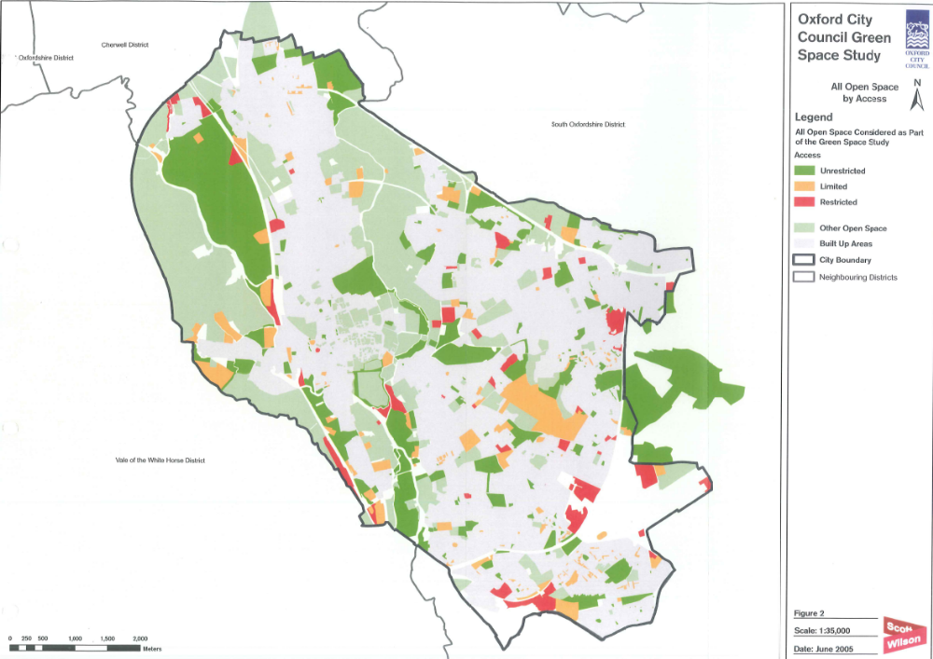
Appendix 1b: Oxford City Council Owned Sites
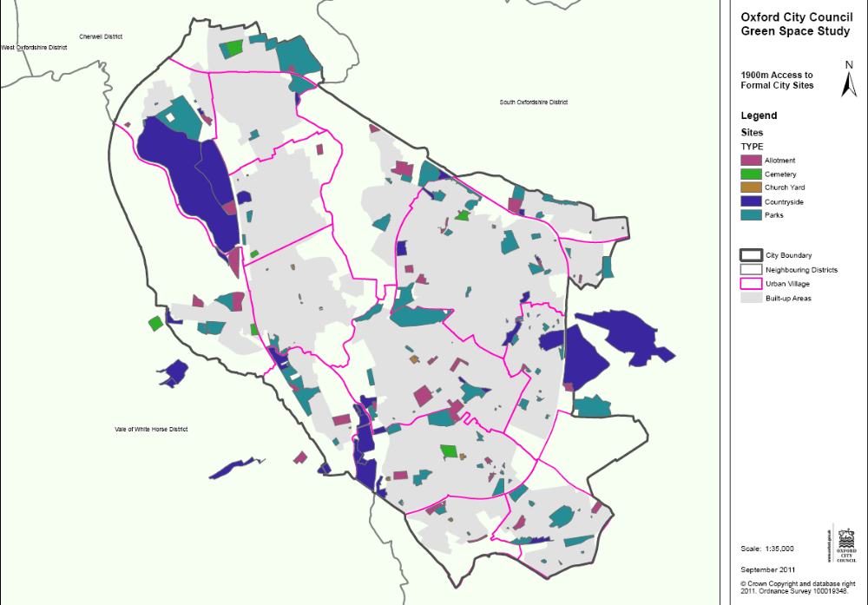
Appendix 1c: Play Area Distribution

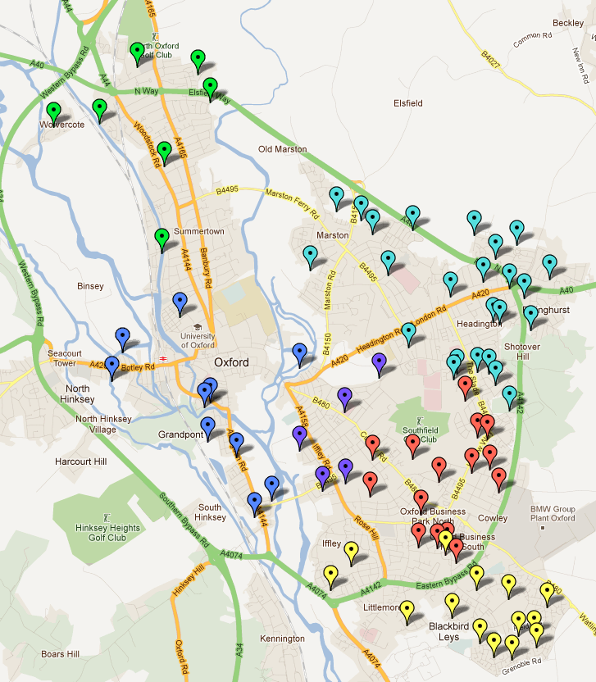

Play Area Site Map
The map shows the location of play areas in Oxford.
Key
Sites where refurbishment has been completed
Red flag - Sites being refurbished in financial year 2009/2010
Blue flag - Sites being refurbished in financial year 2010/2011
Pink flag - Other play areas in Oxford

©2011 Google Map ©2011 Tele Atlas

Appendix 1d: Allotment Distribution

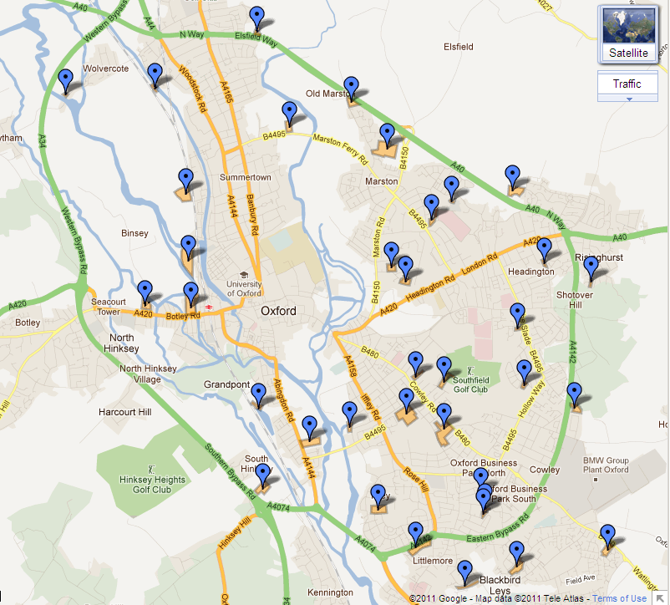©2011 Google Map ©2011 Tele Atlas

Appendix 2: Classification according to a hierarchy - Definitions of Large, Medium and Small Parks

 | Also Known as: | Description | Examples
Large Park | City Park (Scott Wilson Report) | Of a significant size (vary between 7 ha and 122 ha), with secure boundaries and prominent entrances. Usually of a historical significance and sub-regional importance. A high quality landscape comprising a range of elements inc. sports facilities, play areas for all ages and car parking. Likely to have a wide catchment area and significant weekend use. | Cutteslowe & Sunnymead Park  Hinksey Park  Florence Park
Medium Park | Neighbourhood Park (Scott Wilson Report) | Intimate relationship with local neighbourhood. Provision of a flexible space, with prominent trees, possibly with some planting and shrubbery’s. With sports facilities such as fenced off-basket ball hoops or multi use games area (MUGA) or Street Sport site. Children’s play area and extensive site furniture often including youth shelter. | Fry’s Hill Park  Botley Park  Headington Hill Park
Small Park | Local Park (Scott Wilson Report) | To serve the immediate locality and needs. Often containing some children’s play equipment, but not necessary, | John Allen Park  Ridgefield Road Recreation Ground  Gaisford Road Recreation Ground

Appendix 3: Extract from Green Spaces Study showing variance via urban village to quantity standard

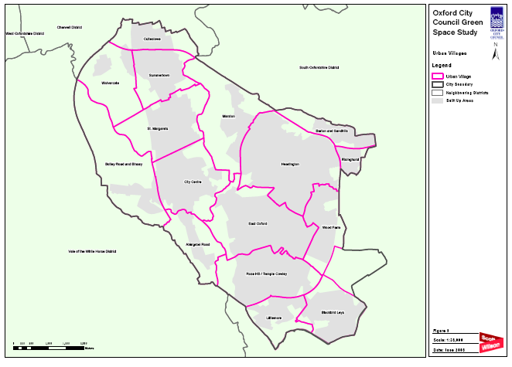
1
7
4
3
51
2
9
8
6
15
10
16
14
13
12
11
Urban Village | Supply  Variance (Urban village/City) +/-
1. Cutteslowe | +11.16
2. Wolvercote | +70.10
3. Summertown | -4.59
4. Botley Road and Binsey | +1.08
5. St. Margarets | +1.01
6. Marston | -1.02
7. City Centre | -2.59
8. Headington | -3.11
9. Barton and Sandhills | -3.78
10. Risinghurst | -1.61
11. Abingdon Rd | +0.64
12. East Oxford | -2.80
13. Wood Farm | +10.13
14. Rose Hill and Temple Cowley | -1.60
15. Littlemore | -4.75
16. Blackbird Leys | -3.50

Appendix 4: 1900m Walking Distance to Formal Large Parks
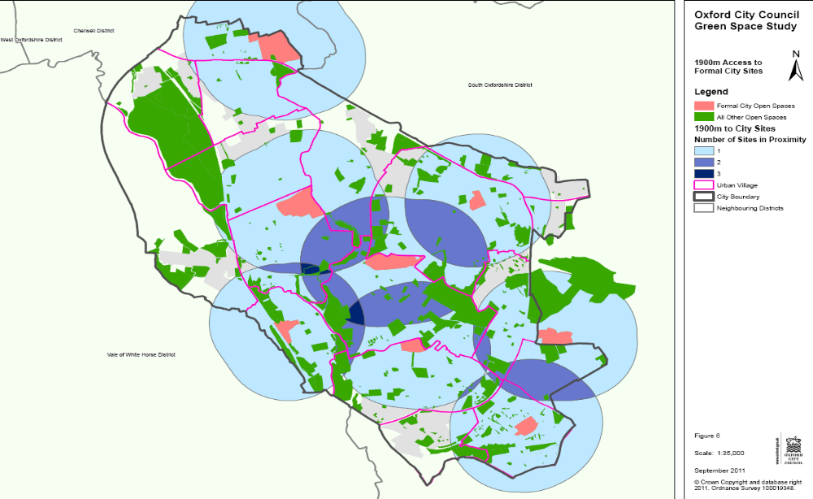
Appendix 5
City Leisure & Parks
Parks and Open Spaces Specification Executive Summary (February 2011)

1. Introduction

1.1 This summary highlights the purpose of the Parks and Open Spaces specification and provides headline information to Officers, Councillors and the public on the standard of works that we aim to achieve.

2. Purpose of the Specification

2.1 The specification illustrates the way in which we deliver services in the following areas; parks maintenance, outdoor sports facilities, pavilions, litter picking, litter and dog bin emptying, park patrols, cemetery management and maintenance, tree works (including planting), playground maintenance and countryside maintenance.

3. Headline Standards:

- Litter and Bin Emptying
  - Bins are emptied at the same time as litter picking is undertaken. The frequency varies depending on the usage of the parks from daily in high use parks to weekly in low use parks
- Grass Cutting
  - The majority of grassed areas, termed standard in the full specification, are cut on a 10 working day cycle between late March and early November
- Sports Turf
  - Maintained to a standard suitable for amateur leagues
  - Marked out to rules of the individual sport
- Shrub Beds
  - City Parks and Green Flag Parks are maintained monthly
  - The majority of shrub beds, termed standard in the full specification, are pruned and maintained twice per annum
- Hedges
  - The majority of hedges, termed standard in the full specification, are cut twice per annum
  - Countryside hedges are cut once per annum
- Tree Maintenance
  - Tree maintenance inspections are carried out as a Parks Management function every three years
  - The tree team carry out work as required from the above inspections or inspections undertaken due to customer enquiries
- Pavilion and toilet Maintenance
  - Pavilions cleaned a minimum of once per week
  - Parks toilets cleaned daily
- Playground Maintenance
  - Weekly inspections undertaken
  - Monthly report of repair work carried from weekly inspections
  - Independent engineer checks undertaken every six months

- We also offer a 24 hour out of hours service – 07711 439 090

3.1 The appendices show a summarised frequency table of all of the activities that are covered in detail the full service specification.

3.2 The specification will be reviewed on an annual basis and agreed at the Council’s Direct Service Board meeting.

  - Sites are also monitored to ensure the standards in the specification are being consistently delivered.

  - This document is only a summary of the specification and the full specification should be viewed for a complete understanding of the standards we aim to achieve. A full copy of the specification is not on the website as it is a working document however it is available from HUparks@oxford.gov.ukUH.

Appendices:
- Parks maintenance table of frequencies
- Fine turf table of frequencies

Blue Sky Green Space: Understanding the importance of retaining good quality Park and Green Space and the contribution they make to improving peoples lives, GreenSpace 2011
Michelle Parker, GreenSpace South East Manager
2009 Place Survey – A national survey to report against National Indicators. The minister for Housing and Local Government cancelled The Place Survey in 2010.
2004 CABE Public Attitudes to Architecture and Public Space, by MORI
Oxfordshire Population and Household Forecasts 2010, Oxfordshire County Council
One hectare (ha) is approximately the size of an international rugby pitch
Oxford City Green Space Study, Scott Wilson, 2005, text update 2007
A Place To Grow, Dr Richard Wiltshire, Local Government Association (LGA) and Communities and Local Government (CLG), 2010
Natural England, Nature Nearby Accessible Natural Greenspace Guidance 2010
Ha-ha walls typically formed a boundary between the estate's gardens and grounds. These walls were constructed so as to be invisible from the house, ensuring a clear view across the estate.
Blue Sky Green Space: Understanding the importance of retaining good quality Park and Green Space and the contribution they make to improving peoples lives, GreenSpace 2011
Be Active, Be Healthy, 2006/7 measure cost of inactivity
Blue Sky Green Space: Understanding the importance of retaining good quality Park and Green Space and the contribution they make to improving peoples lives, GreenSpace 2011

